NAMA : Taufiq Hidayah

NIM : 2101720901

=====================================================================

Client

|  |
| --- |
| import socket  def encrypt(string, shift):    cipher = ''  for char in string:  if char == ' ':  cipher = cipher + char  elif char.isupper():  cipher = cipher + chr((ord(char) + shift - 65) % 26 + 65)  else:  cipher = cipher + chr((ord(char) + shift - 97) % 26 + 97)    return cipher    # text = input("enter string: ")  # s = int(input("enter shift number: "))  # print("original string: ", text)  # print("after encryption: ", encrypt(text, s))  s = socket.socket()  s.connect(('127.0.0.1',12345))  print("Connection initialed...")  print("Type exit to finish sending data")  while True:  print("Enter your message:")  print("This is a new message")  str = input("Enter the key number 1-26 \n ")  # if s.str()    s.send(str.encode())  if(str == 0):  s.send(str.encode())  break  # print ("N:",s.recv(1024).decode())  s.close() |

Server

|  |
| --- |
| import socket  import datetime  def encrypt(string, shift):    cipher = ''  for char in string:  if char == ' ':  cipher = cipher + char  elif char.isupper():  cipher = cipher + chr((ord(char) + shift - 65) % 26 + 65)  else:  cipher = cipher + chr((ord(char) + shift - 97) % 26 + 97)    return cipher  s = socket.socket()  port = 12345  s.bind(('', port))  s.listen(5)  c, addr = s.accept()  print ("Socket Up and running with a connection from",addr)  print(datetime.datetime.now())  while True:  date = datetime.datetime.now()  rcvdData = c.recv(1024).decode()  print ("S:",rcvdData)  text = ("This is a new message")  # enc = encrypt(text, int(rcvdData))  print("coded message: %s" % encrypt(text, int(rcvdData)))  print("encode message: %s " % text)  print(date)  # sendData = input("N: ")  conv= str(rcvdData)  f= open("hasil.txt","a+")  f.write(str(rcvdData)+','+str(date) + ','+encrypt(text, int(rcvdData))+'\n')  # c.send(sendData.encode())  if(int(rcvdData)==0):  break  c.close() |

Result

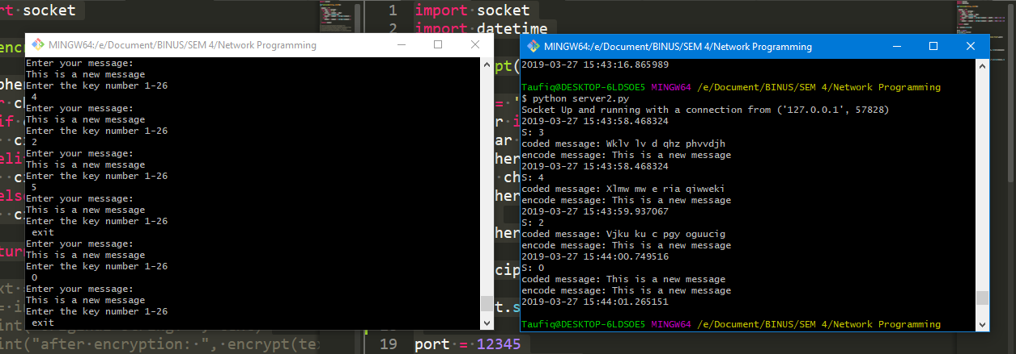

FILE PROCESSING

